CRT MFD Manual

1 Introduction
CRT MFD simulates some of the Shuttle’s displays. It also acts as an interface for the GPCs on the Shuttle.

2 Shuttle GPCs
The General Purpose Computers, or GPCs, have several different modes, depending on what portion of its flight the shuttle is in. For example, Major Mode 101 (MM101) is used before launch. MM201 covers most of the on-orbit phase, while MM202 is used to perform engine firings while in orbit. Each mode has at least one display associated with it (only a few are currently simulated). In each display, there are different items. Each item controls a different setting. Note that these displays can only be accessed from the three central MFDs on the forward flight deck (MFD1, MFD2, MFD3) and the starboard workstation MFD (MFD4).

2.1 Keyboard Entry
The MFDs are controlled by the keyboards on the flight deck. The starboard MFD is controlled by the keyboard below it. The forward flight deck MFD is controlled by the two keyboards on the centre console. The left keyboard controls either the central MFD (3) or the upper left MFD (1), depending on the LEFT CRT SEL switch setting. Similarly, the right keyboard either controls the central (3) or upper right (2) MFD.

To change MM: press OPS, followed by 3-digit number, then PRO
To change SPEC: press SPEC followed by number, then PRO. Press RESUME to return to the standard display.
To enter ITEM: press ITEM followed by item number, then EXEC.
To enter ITEM (with data entry): press ITEM followed by ITEM number, then data (preceeded by + or – sign), then EXEC.

3 MM104 (OMS 1)
This mode is used for the OMS-1 burn, sometimes performed shortly after ET Sep. It is essentially identical to MM202 (On-orbit maneuver). This mode will be entered automatically after ET Sep.

4 MM105 (OMS 2)
This mode is used for the OMS-2 burn. It is essentially identical to MM202 (On-orbit maneuver). This mode must be manually entered from MM104.

5 MM106
This mode must be manually entered from MM105.

6 MM201
This mode is used for most on-orbit operations. It has two displays, UNIV PTG (Universal Pointing) and DAP CONFIG. It must be manually entered from MM106 or MM202.

6.1: UNIV PTG
This display is used to control the DAP (Digital Autopilot) of the Shuttle, which keeps the Shuttle pointed in a particular direction.
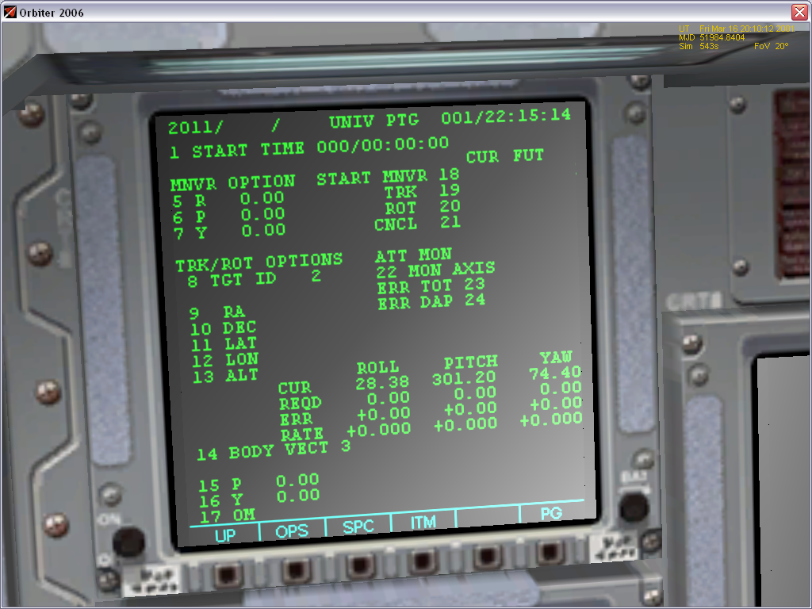
Items 1-4: Used to set START TIME. The autopilot will automatically maneuver to the correct attitude once the MET (displayed in the upper right corner of the MFD) is greater than the start time inputted.

Items 5-7: Used to input Roll, Pitch and Yaw angles. These angles are used to input an inertial attitude.
Items 8-13: Currently unused (will be functional in a future release)

Items 14-17 are used for TRK Mode.
Item 14: Selects vector to be pointed at orbit reference. BODY_VECT=1 will use +X vector (through nose). BODY_VECT=2 will use -X vector (through tail). BODY_VECT=3 will use -Z vector (through top of craft). BODY_VECT=5 will use a user-defined vector.
Item 15: Pitch component of user-defined vector.
Item 16: Yaw component of user-defined vector. An entry of 0 Pitch and 0 Yaw corresponds to a vector parallel to the +X axis. An entry of 270 Pitch and 0 Yaw corresponds to a vector parallel to the +Z vector. An entry of 0 Pitch and 270 Yaw corresponds to the vessel beigng placed in the standard prograde orientation.
Item 17: Set Omicron angle. This rotates the spacecraft around the Body Vector. (changes Yaw angle)

Item 18: Engage MNVR mode. This will maneuver the vessel to the desired inertial attitude.
Item 19: Engage TRK mode. This will maneuver the vessel to the proper attitude relative to the orbit reference.
Item 21: Cancel attitude mode. This will turn off any selected attitude mode. If you make any changes to the MFD settings (desired attitude, etc.) you must cancel, then re-engage the autopilot for the changes to take effect.

The ROLL, PITCH, YAW section in the lower right corner of the display displays the current attitude, target attitude (valid only if MNVR mode is engaged), attitude error (valid only if MNVR mode is engaged) and rotation rates. All measurements are in an inertial frame of reference.

6.2: DAP CONFIG (SPEC 20)
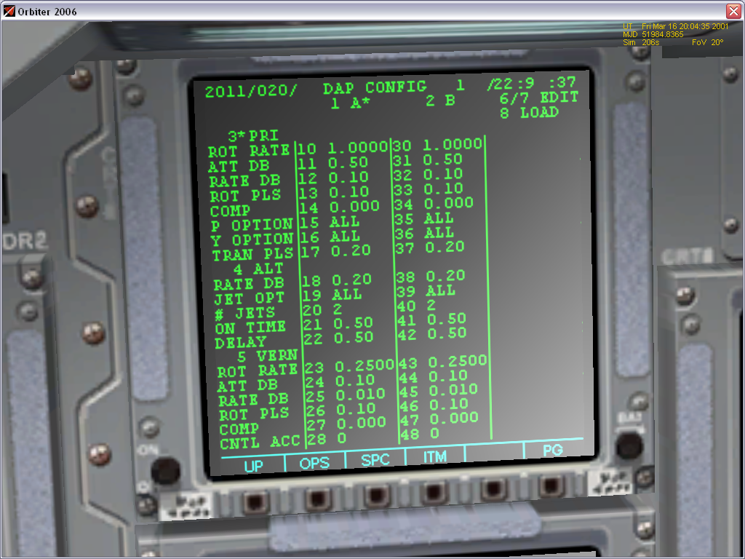
This display is used to set the parameters used by the DAP, such as attitude and rate deadbands. When the DAP is in PRI of ALT modes, the thrusters are used at full power, but the DAP uses the thrusters at 10% while in VERN mode.

Item 1: Select A DAP. This will cause the autopilot to use the parameters in the A column of the display.
Item 2: Select B DAP. This will cause the autopilot to use the parameters in the B column of the display.
Item 3: Select PRI DAP mode. This will cause the autopilot to use the PRI settings.
Item 4: Select ALT DAP mode. This will cause the autopilot to use the ALT settings.
Item 5: Select VERN DAP mode. This will cause the autopilot to use the VERN settings.
Item 6: Edit A DAP. This will copy the parameters for the A DAP into the Edit column.
Item 7: Same as Item 6, but for B DAP.
Item 8: Load DAP. This will copy the parameters in the Edit column to the appropriate (A or B) DAP.
Items 10-17: Set PRI parameters for A DAP.
ROT RATE: Maximum commanded rotation rate (in DISC RATE mode).
ATT DB: Maximum allowable difference between current and target attitude.
RATE DB: Maximum allowable difference between current rotation rate and commanded rotation rate.
ROT PLS: Magnitude of single rotation pulse (in PULSE mode).
COMP: Unused.
P OPTION: Select set of RCS thrusters to be used for pitch maneuvers. NOSE will only use front jets, TAIL will only use aft jets, ALL will use all jets.
Y OPTION: Same as P OPTION, but in yaw axis.
TRAN PLS: Magnitude of single translation pulse (in PULSE mode).
Items 18-22: Set ALT parameters for A DAP.
JET OPT: Select between using ALL jets of only TAIL jets.
# JETS: Unused.
ON TIME: Unused.
DELAY: Unused.
Items 23-27: Set VERN parameters for A DAP.
Item 28/48: Unused.
Items 30-37: Set PRI parameters for B DAP.
Items 38-42: Set ALT parameters for B DAP.
Items 43-47: Set VERN parameters for B DAP.

7 MM202
This mode is used to perform burns using the OMS engines. It must be manually entered from MM201.
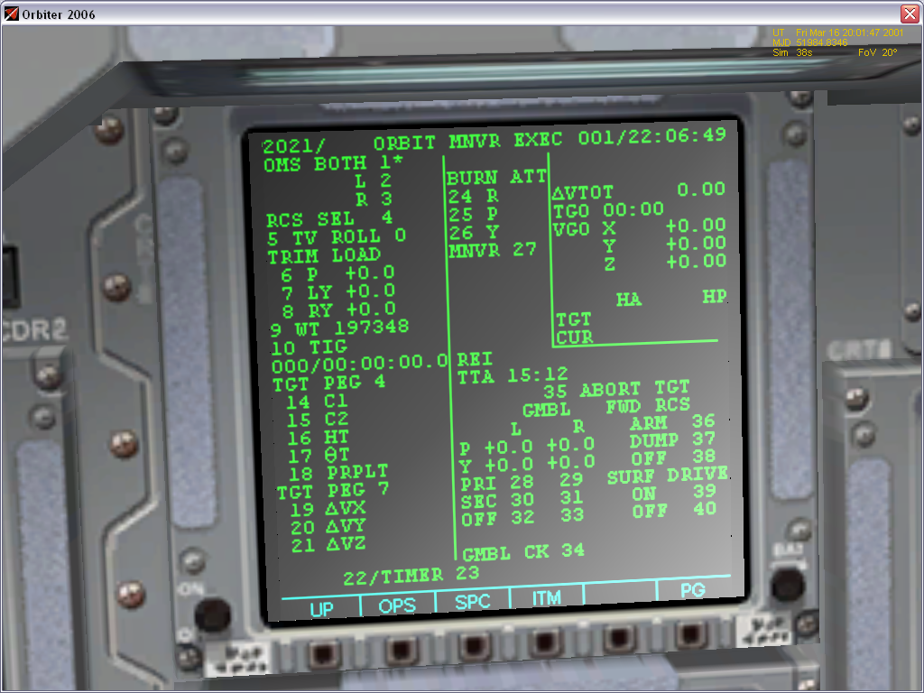
Items 1-4: Select Engine(s) to be used. Note that an RCS burn is not currently supported.
Item 5: Set roll angle at ignition. Usually set to either 0 (heads up) or 180 (heads down).
Items 6-8: Set engine gimbal angles, to avoid torque while firing. See flight checklists for recommended settings.
Item 9: Set the weight of the orbiter in pounds. This value is automatically set when MM202 is loaded.
Items 10-13: Set TIG (Time of Ignition). TIG is given in MET (Mission Elapsed Time), which is displayed at the upper-right corner of the screen.
Items 14-18: Unused.
Items 19-21: Target ΔV in X, Y and Z axes in feet per second(fps) in an LVLH reference frame. The +X vector is parallel to the velocity vector. The +Z vector points toward the centre of the Earth. The +Y vector points toward the south and is perpendicular to the +X and +Z vectors.
Item 22: Load Maneuver. This should be executed after all data has been inputted.
Item 23: Display a timer counting down to ignition below the MET display.
Items 24-26: Display target attitude at ignition. These values are automatically computed when Item 22 is executed.
Item 27: Maneuver to burn attitude.

ΔVTot displays the total delta v in fps.
TGO shows the total burn time, or, if the burn is in progress, the time remaining until cutoff.
VGO shows the velocity to be gained (in fps) in orbiter body coordinates.

9 MM301
This mode is used to setup the deorbit burn. It must be manually entered from OPS 201. It is essentially identical to MM202, but cannot actually perform a burn.

10 MM302
This mode is used to perform the deorbit burn. It must be manually entered from OPS 301. It is essentially identical to MM202.

11 MM303
This mode is used between the deorbit burn and entry interface. It must be manually entered from OPS 302. It is essentially identical to MM106.

12 Other Displays
These displays can be used in any mode.
12.1 OMS
This display shows data for the OMS and SSME engines.

He Tk P displays to pressure in the helium tanks used to pressurize the OMS fuel tanks.
Pc displays the throttle setting of the engine.

12.2 APU
This display shows data for the APU and Hydraulic systems.
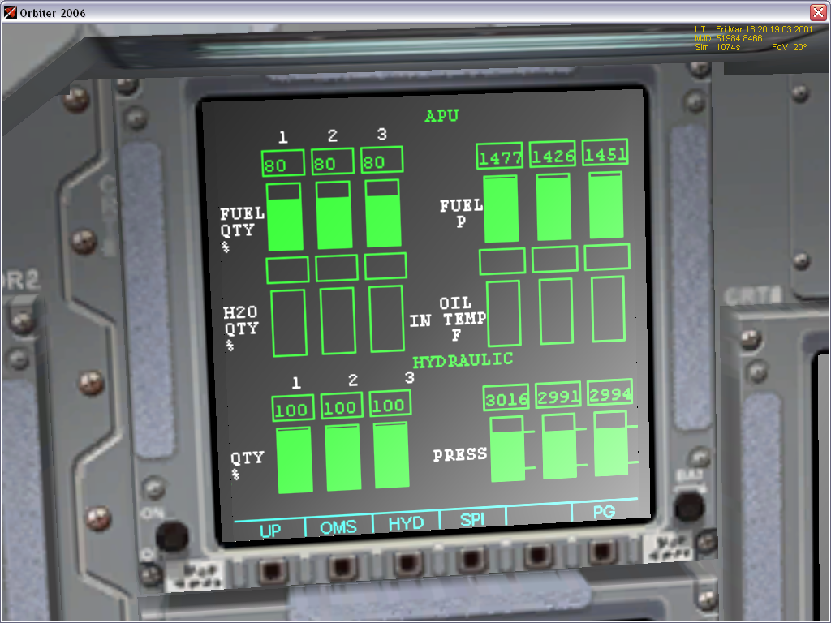
FUEL QTY shows the percentage of APU fuel remaining.
QTY shows the amount of hydraulic fluid remaining.
FUEL P shows the rate at which APU fuel is being discharged. This should be ~1400-1500 when the APUs are running.
HYDRAULIC PRESS shows the hydraulic system pressure. This should be ~3000 when the APUs are running.

12.3 SPI
This display shows the position of the aerosurfaces.
For all displays except the bodyflap, the zero-deflection position is indicated by a 0 on the scale.
For the bodyflap, the zero-deflection position is indicated by a triangle.
